AuthoMail Monitoring

We have developed a feature for monitoring AuthoMail easily by just looking the Heart Shaped Icon’s color on the menu bar.
Here are the details of what do the Heart’s color represent in AuthoMail:
- White Color: AuthoMail is working normal.
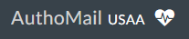
- Red Color with Blink: If AuthoMail fails to process files in adequate time then Heart will be red.
  - Action To Perform : Dev team should be contacted immediately. Any delay will mostly likely result in fulfillment issues.
  - If there is a batch available to process on SFTP from 1 hour and still AuthoMail does not process it then Heart’s color will be RED and it will start blinking.
  - If batch is not submitted to print vendor within 45 minutes then Heart’s color will be RED and it will start blinking.
  - 
- Yellow Color: If due date is passed and still no response received from print vendor then Heart’s color will be YELLOW.
  - Action To Perform : Need to contact print vendor for batch status if printing and shipping is completed within SLA or not.
- Yellow Color with Blink: If we received response from print vendor but did not processed in AuthoMail then Heart’s color will be YELLOW and it will start blinking.
  - No fulfilment issues, only that AuthoMail is failing to send reports out. Print vendor or Dallas team has completed shipping.

- By clicking on Heart Icon, AuthoMail will display “AuthoMailHealth” page.(Screenshot attached)
  - There are four (4) processes displayed.
    - Download, Process, Printer, Reporting.
  - If everything is normal in AuthoMail then all 4 processes will be in GREEN color else it turns into RED color.
    - E.g. If there is a delay in getting a response from Print Vendor then “Printer” color will change to RED.
  - Page will also display count of affected batches and mail pieces.
    - To view full details of batches and mail pieces click on “View Details”.(Screenshot attached)

AuthoMail Health Page
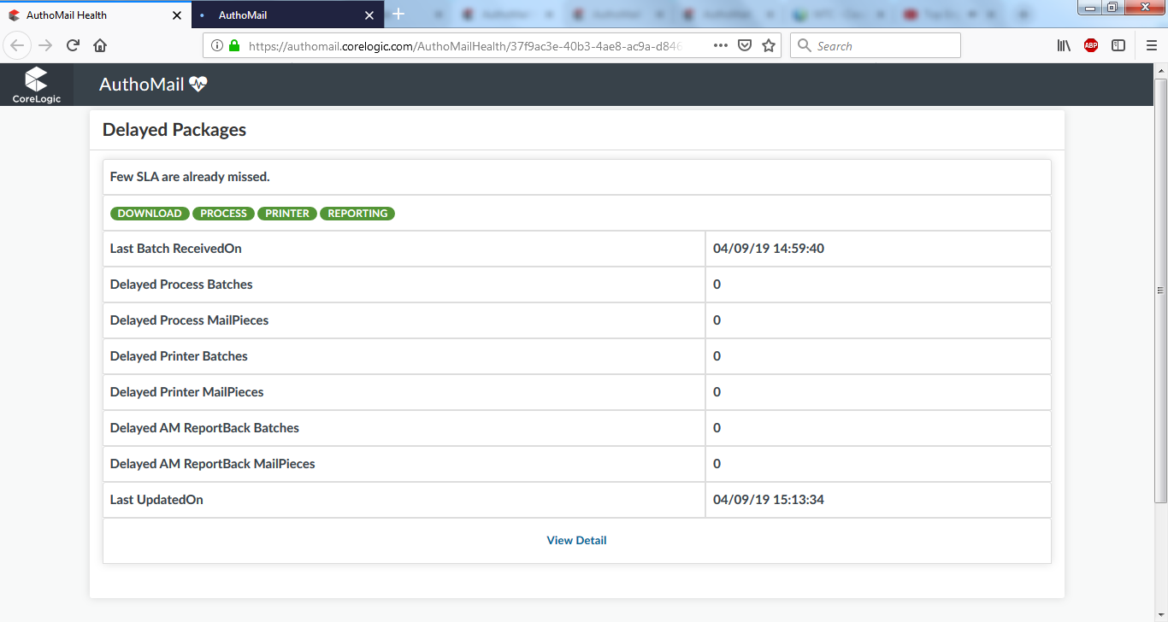

Details Page:
